A Project Stage-I Report on

**Peltier Refrigerator**

By

*Mr*. Chougule Nishant Dilip Exam. Seat No.B190360884

*Mr*. Shelke Dhananjay Vilas Exam. Seat No.B190361193

*Mr.* Shelke Mayur Eknath Exam. Seat No. B190361194

*Mr*. Kokane Tejas Vikas Exam. Seat No.B190361237

**Guide**

Prof. R.R. Yenare



Department of Mechanical Engineering

Sinhgad Technical Education Society’s

Smt. Kashibai Navale College of Engineering

[2022-23]

Sinhgad Technical Education Society’s

Smt. Kashibai Navale College of Engineering



**C E R T I F I C A T E**

This is to certify that *Mr*. Chougule Nishant Dilip Exam. Seat No.……………….

*Mr*. Shelke Dhananjay Vilas Exam. Seat No.……………….

*Mr.* Shelke Mayur Eknath  Exam. Seat No.……………….

*Mr*. Kokane Tejas Vikas Exam. Seat No.……………….,

have successfully completed the Project Stage – I entitled “*Peltier Refrigerator*” under my supervision, in the partial fulfillment of *Bachelor of Engineering - Mechanical Engineering* of Savitribai Phule Pune *University.*

Date: - 21/11/2022

Place: - Pune

|  |  |
| --- | --- |
| ***Prof. R. R. Yenare***  ***Guide*** | ***Prof…………….***  ***External Examiner*** |
| ***Prof. T. S. Sargar* Head of Department** | ***Dr. A.V. Deshpande***  **Principal** |

**ACKNOWLEDGEMENT**

I take this opportunity to thank all those who have contributed in successful completion of this Project Stage -1 work. I would like to express my sincere thanks to my guide **Prof. R.R. Yenare** who have encouraged me to work on this topic and provided valuable guidance wherever required. I also extend my gratitude to **Prof. T. S. Sargar (H.O.D Mechanical Department)** who has provided facilities to explore the subject with more enthusiasm.

I express my immense pleasure and thankfulness to all the teachers and staff of the **Department of Mechanical Engineering of Smt. Kashibai Navale College of Engineering** for their co-operation and support.

*Mr*. Chougule Nishant Dilip Sign.……………….

*Mr*. Shelke Dhananjay Vilas Sign.……………….

*Mr.* Shelke Mayur Eknath  Sign.……………….

*Mr*. Kokane Tejas Vikas Sign.……………….

**ABSTRACT**

A large distribution of people living in developing countries irrespective of areas where the major problem at present is lack of electrification to provide refrigeration. Grid power is presently unavailable and is not imagined in the divine future. Refrigeration systems driven by the thermal combustible organic material have efficiency about 35% in average and leads emission of greenhouse gas . Since, conventional electrically powered refrigeration system may not be much use in those areas, for basic applications such as food and drug preservation, alternative refrigeration system is required. Solar energy is confirmed to be an ideal source for a low temperature heating application. Three known sound out that use solar energy to produce refrigeration at temperature below 0⁰C include solar i.e. photovoltaic (PV) operated refrigeration, absorption refrigeration and solar mechanical. Among these approaches, the photovoltaic (PV) system or solar thermal energy by using Thermoelectric Technology , the most feasible and appropriate means for portable systems irrespective to any location , can call as freezer on wheels. Thus the refrigerator is eco-friendly, without fluorine pollution ,small volume, and absence of moving parts in system. Solar-powered refrigerators are typically used in off-grid locations where utilities provided AC power is not available, but we can implement these irrespective to several conditions to meet the future and utilize the conventional sources in vast possible ways. By this project we have archived the instance cooling and adequate coefficient of performance of the system to any locations easily. This project will serve the purpose of providing a portable refrigerator for medical team or emergency teams to carry things in remote areas and in areas where electricity supply is not reliable.

**LIST OF FIGURES**

Figure 1: Portable Refrigerator

Figure 2: Portable systems

Figure 3: Structure of Peltier

Figure 4: TEC Module

Figure 5: Explanation of number on tec

Figure 6: Performance Curve

Figure 7: Dimension of tec

Figure 8: Battery

Figure 9: Solar Panel

Figure 10: Working of solar

Figure 11: Peltier Module

Figure 12: Drafting of Peltier module

Figure 13: Heat Sink

Figure 14: Temperature Sensor

Figure 15: Battery

Figure 16: Isometric view

Figure 17: Assembly

**LIST OF TABELS**

Table 1: Peltier Characteristics

**TABLE OF CONTENTS**

1.INTRODUCTION 9

1.1 PROBLEM DEFINITION 12

1.2 OBJECTIVE 13

2. LITERATURE REVIEW 14

2.1. Thermoelectric Module 14

2.1.1. Components 16

2.1.2. Solar cell 20

3. DESIGN AND METHODOLOGY 25

3.1. CAD Model 25

3.2. Calculation 28

3.3. Selection of Material 29

3.4. Activity Chart 31

3.5. Methodology 32

3.6. Advantages 33

3.7. Disadvantages 33

3.8. Applications 33

4. CONCLUSION 35

4.1. Conclusion 35

4.2. Advantages of Having a Portable Mini Fridge 36

4.2.1. Positioning 37

4.2.2. Reliable With Energy 37

4.2.3. Fits Just About Anywhere 37

4.2.4. Ease and Comfort 37

4.3. FUTURE SCOPE 38

4.3.1. Using Two TECS Totalling the Designed Qc 38

4.3.2. Developing a Suitable Power Sharing Regulator 38

5. REFERENCES 39

# **1.INTRODUCTION**

There are many products currently in the market that have the ability to preserve ice, including mini and electric portable refrigerators and freezers. But these options are either not truly portable or cannot consistently maintain the desired temperature. Coolers use ice that melts. Portable refrigerators and freezers are limited to an AC/DC power source that is bulky and difficult to move from place to place, thereby limiting where it's transportability. The Peltier refrigerator is our solution to an array of problems relating to the lack of portable refrigeration. The applications of how and where this product can be used are endless. The Peltier refrigerator is a portable, self-sustaining, solar-powered, collapsible refrigerator and freezer that can go anywhere!

Designed for Quality and Reliability

The Peltier refrigerator is a mobile refrigerator that is powered using solar panels, fully collapsible to haul around anywhere, and completely weather resistant. Perfect for picnics at the park to keep your food fresh, keeping your brewskies chilled while listening to crunchy tunes at a music festival, or maybe you just can't go 10 minutes without eating a cheeseburger, so you haul around an entire refrigerator to fulfill your appetite so that your meat doesn't go bad.

You can charge the Peltier Refrigerator before you go out and if the sun goes down or you run out of sunlight, the battery will kick in and continue cooling your food/beverages/dead body until the sun is back, and better yet you can leave it outside all year long as it is weather proof.

A fridge, a freezer, a solar-powered wonder child called the Anywhere Fridge. Portable for camping and sturdy and weather-resistant for transport or permanent outdoor installation, this wheeled powerhouse of food preservation.

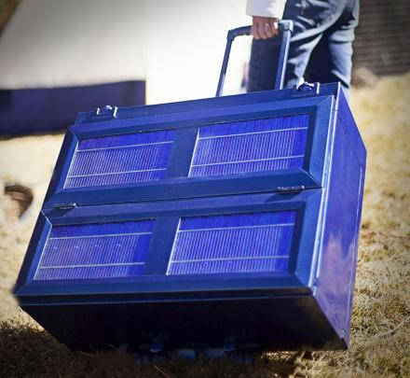

Fig 1: Portable Refrigerator

From the ancient age man always prefers to have cold water for drinking purpose. Also in India, our country the weather is too hot. Particularly in summer season, the normal water temperature in open space is 35 to 380 C. The water is not suitable for drinking purpose. The required temperature is at the most 250 C. Hence lowering down of the temperature is an essential task.

In old age there was ample space available to keep the earthen container also the houses were sheltered by the trees and bushes which were enough to lower down the water container temperature. Because in most of the situations the temperature depends upon the temperature of the flowing air.

The different water-cooling processes incorporated are since old age are as follows: -

* Earthen pots
* Using ice

Cooling of water in earthen pot is one of the earliest methods employed by men for cooling the water in their houses. Only in recent years, it has been put on sound footing thermodynamically. It is a process of adiabatic saturation of air when cooling of surface water on container is made to evaporate to cool with transfer of heat from water to the surroundings. The initial investment cost of such a system is low & the operation is simple & cheap. Simple evaporative cooling is achieved by direct contact of water particles & a moving air stream. The water may be sufficiently cooled by evaporative process to results a considerable degree of drinking comfort in climates of high dry-bulb temperatures associated with low relative humidity. The minimum outdoor temperature required for successful evaporative cooling is above 350 c & another requirement is a relatively low wet bulb temperature.

Although the evaporative cooling does not perform all the function of true water-conditioning, but it provides coolness by filtering heat & circulating the cooled air. From last century till now refrigeration has been one of the most important factors of our day-to-day life.

The current tendency of the first world is to look at renewable energy resources as a source of energy. This is done for the following two reasons; firstly, the lower quality of life due to air pollution and secondly, due to the pressure that the ever-increasing world population puts on our natural energy resources. From these two facts comes the realisation that the natural energy resources available will not last indefinitely.

A conventional cooling system includes an evaporator, a compressor, and a condenser. In the evaporator the pressurized refrigerant goes through expansion, boiling and then evaporation. When the phase changes from liquid to gas heat energy is absorbed. Then the compressor recompresses the gas into a liquid and the condenser expels the gas to the ambient surroundings. A TE cooling system has similar subassemblies.

However, TE cooling is specifically the abstraction of heat from electronic components. Over the past four decades, improvement in the conversion efficiency has been marginal. The challenge has been the improvement in the performance of the thermo-couple materials, which could lead to a breakthrough in terms of the efficiency of the TE device.

Hence conventional refrigerators were invented which worked on refrigerant and thermodynamic cycle. Refrigeration serves human beings throughout their life. It has found tremendous application in manufacturer of ice, preservation of food and air conditioning. The basic idea is implementation of photovoltaic driven refrigerating system powered from direct current source or solar panel with a battery bank. It is different from conventional refrigeration system and based on peltier effect. It uses Thermo-electric module which replace bulky parts in conventional refrigerator as there is no working fluid.

A developed model of commercial thermoelectric refrigerators with finned heat exchanger is established. The aim of this chapter is to present some fundamental aspects of the direct thermoelectric conversion. Thermoelectric systems are solid-state heat devices that either convert heat directly into electricity or transform electric power into thermal power for heating or cooling. Such devices are based on thermoelectric effects involving interactions between the flow of heat and electricity through solid bodies

These phenomena, called Seebeck effect and Peltier effect, can be used to generate electric power and heating or cooling. Solar energy is the lowest cost, competition free, universal source of energy as sunshine's throughout. And the theory existed in 1911; the materials available were not suitable for effective cooling. Metals have good electrical conduction but good thermal conductivity as well. This allowed for a very low COP (co-efficient of performance) of one per-cent due to the thermal conductivity of the metal from the hot side to the cold side of the TEC It was only since the 1950's with the discovery of semiconductors, that the COP was increased. Semiconductors had the same electrical conductivity as metals but much lower thermal conductivity. This provided for a much-improved COP of twenty percent. Typical material composition is alloys of the elements Bi, Cd, Sb, Te, Se and Zn.

This energy can be converted into useful electrical energy using photovoltaic technology. Thermo-electric refrigeration replaces the three main working parts with: a cold junction, a heat sink and a DC power source. The refrigerant in both liquid and vapour form is replaced by two dissimilar conductors. The cold junction (evaporator surface) becomes cold through absorption of energy by the electrons as they pass from one semiconductor to another, instead of energy absorption by the refrigerant as it changes from liquid to vapour. The compressor is replaced by a DC power source which pumps the electrons from one semiconductor to another. A heat sink replaces the conventional condenser fins, discharging the accumulated heat energy from the system. The difference between two refrigeration methods, then, is that a thermoelectric cooling system refrigerates without use of mechanical devices, except perhaps in the auxiliary sense, and without refrigerant.

The TEC cooler will utilise the power from the PV (photo-voltaic) panels when the battery is fully charged, and at night, will use a small amount of power to maintain the temperature in the cooler box. In. other words, if the battery of the system is fully charged, and there is no appliance to absorb the power generated from the PV panel, it would be wasted, resulting in a 'poor efficiency factor for the whole PV system. The cooler box integrated in a RAPS (remote area power supply) would allow for a very efficient system utilising all the excess generated power from the sun. Sun energy is use for cooling therefore, the more the sun shines, the warmer it gets, and the more power there will be for cooling

.

## **PROBLEM DEFINITION**

The Peltier Refrigerator liberates the convenience of industrial refrigeration from the limitations of your home. It runs off detachable solar panels which simultaneously charge the built-in lithium-ion battery. On one complete charge, the Peltier Refrigerator can last a full night.

We want to have access to a fully functional refrigerator wherever and whenever, whether you are camping, tailgating, caught in a natural disaster or without power for days. The Peltier refrigerator is equipped to perform like an industrial-strength refrigerator while being portable and accommodating, making it perfect for the outdoors person, the frugal minded and the utilitarian.

Seebeck did not actually comprehend the scientific basis for his discovery, however, and falsely assumed that flowing heat produced the same effect as flowing electric current.

In 1834, a French watchmaker and part time physicist, Jean Peltier, while investigating the "Seebeck Effect," found that there was an opposite phenomenon whereby thermal energy could be absorbed at one dissimilar metal junction and discharged at the other junction when an electric current flowed within the closed circuit. And it is the fundamental principal behind a thermo-electric system.

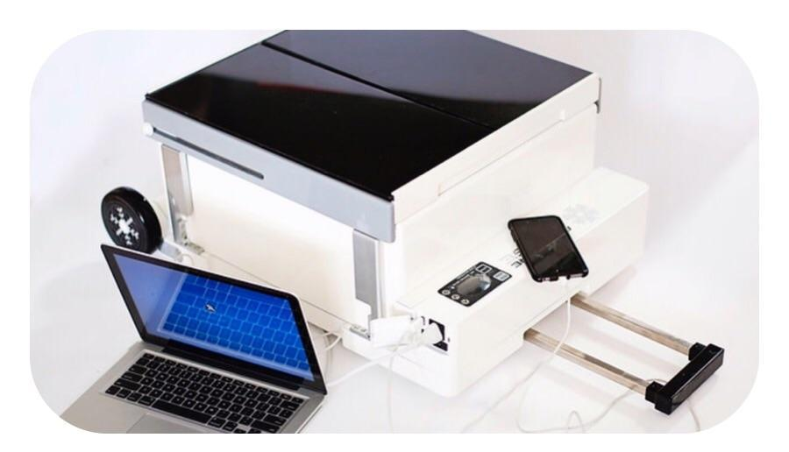

Fig 2: Portable systems

Using different metals produced cooling devices that had very poor co-efficient of performances (COP). This was because materials with high temperature conduction co-efficient were used partly because of excessive temperature conduction between the hot side and the cold side of the thermo-electric heat exchanger. Since the discovery of semiconductors, the co-efficient of performance of the TEC was drastically improved since materials could be used with low temperature conduction co-efficient but by doping it, the semiconductor could be made to conduct, exerting electrical conduction properties found in metal.

## **1.2OBJECTIVE**

There are so many refrigerators available in market but they have their own limitations due to which they are they are not beneficial for special purposes. Our main objective in this project is to develop a low-cost portable solar powered refrigerator for special and small needs. The design should be simple and the size must be compact to carry. It should be light weight in nature and does not require any external power source for operation other than solar.

# **2. LITERATURE REVIEW**

*Awasti, M., & Mali, K. (2012).* Design and Development of Thermoelectric Refrigerator. International Journal of Mechanical Engineering and Robotics Research(Volume No. 3). The retention time achieved was 52 min with the designed module in this project. To achieve a higher retention time, another alternative was incorporated. This consists of the additional heater on a heat sink.

*Chetan Jangonda, K. P. (2016).* Review of various Applications of Thermoelectric Module. Thermoelectric cooling added a new dimension to cooling. It has a major impact on a conventional cooling system. It is compact in size, no frictional elements are present, no coolant is required and the weight of the system is low.

*D. Suman, p. H. (2020). Design and fabrication of thermoelectric refrigerator using peltier module*. The efficiency and life of the Peltier refrigerator are maximized by using these water pockets and the temperature was controllable by changing the input voltage and current so we can maintain the things at the required temperature. Finally, it has been recorded the minimum temperature i.e., 2°c.

*Jatin Patel, M. P. (2016). Improvement in the COP of Thermoelectric Cooler*. This study experimentally investigates the performance of the single-stage and multistage TEC air-cooling module. It is quite easy to achieve a significant temperature difference in the single-stage TE module, but, the COP of the single-stage module is very less for domestic use. In the multistage TE module, it is possible to get the required COP as well as better thermal performance.

*Kshitij Rokde, Mitali Patle, T. k. (2017). Peltier Based Eco-Friendly Smart Refrigerator for Rural Areas.* The efficiency of the refrigerator can be increased by increasing the number of Peltier plate modules which will eventually help in decreasing the temperature in less time. The number of Peltier plate modules used can be calculated using the heat transfer formula.

*V.rajangam, m. (2015). Design and cfd analysis of thermoelectric cooling system.* The design parameters involved a thermoelectric cooling system. Experimental work is carried out to obtain a temperature up to 5 degrees

## **2.1. Thermoelectric Module**

A typical thermoelectric module is composed of two ceramic substrates that serve as a foundation and electrical insulation for P-type and N-type Bismuth Telluride dice that are connected electrically in series and thermally in parallel between the ceramics. The ceramics also serve as insulation between the module’s internal electrical elements and a heat sink that must be in contact with the hot side as well as an object against the cold side surface. Electrically conductive materials, usually copper pads attached to the ceramics, maintain the electrical connections inside the module. Solder is most commonly used at the connection joints to enhance the electrical connections and hold the module together. Most modules have and even number of P-type and N-type dice and one of each sharing an electrical interconnection is known as, "a couple". While both P-type and N-type materials are alloys of Bismuth and Tellurium, both have different free electron densities at the same temperature. P-type dice are composed of material having a deficiency of electrons while N-type has an excess of electrons. As current (Ampere) flows up and down through the module it attempts to establish a new equilibrium within the materials. The current treats the P-type material as a hot junction needing to be cooled and the N-type as a cold junction needing to be heated. Since the material is actually at the same temperature, the result is that the hot side becomes hotter while the cold side becomes colder. The direction of the current will determine if a particular die cools down or heat up. In short, reversing the polarity will switch the hot and cold sides.

Thermoelectric modules are solid-state heat pumps that operate on the Peltier effect (see definitions). A thermoelectric module consists of an array of p- and n-type semiconductor elements that are heavily doped with electrical carriers. The elements are arranged into array that is electrically connected in series but thermally connected in parallel. This array is then affixed to two ceramic substrates, one on each side of the elements (see figure below).

The heat transfer occurs as electrons flow through one pair of p- and n-type elements (often referred to as a "couple") within the thermoelectric module. The p-type semiconductor is doped with certain atoms that have fewer electrons than necessary to complete the atomic bonds within the crystal lattice. When a voltage is applied, there is a tendency for conduction electrons to complete the atomic bonds.

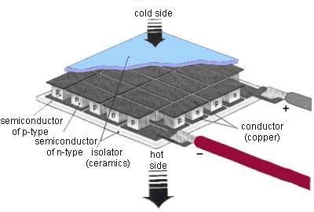

Fig 3: Structure of Peltier

When conduction electrons do this, they leave “holes” which essentially are atoms within the crystal lattice that now have local positive charges. Electrons are then continually dropping in and being bumped out of the holes and moving on to the next available hole. In effect, it is the holes that are acting as the electrical carriers. Now, electrons move much more easily in the copper conductors but not so easily in these micro conductors. When electrons leave the p-type and enter into the copper on the cold-side, holes are created in the p-type as the electrons jump out to a higher energy level to match the energy level of the electrons already moving in the copper. The extra energy to create these holes comes by absorbing heat. Meanwhile, the newly created holes travel downwards to the copper on the hot side. Electrons from the hot-side copper move into the p-type and drop into the holes, releasing the excess energy in the form of heat.

The n-type semiconductor is doped with atoms that provide more electrons than necessary to complete the atomic bonds within the crystal lattice. When a voltage is applied, these extra electrons are easily moved into the conduction band. However, additional energy is required to get the n-type electrons to match the energy level of the incoming electrons from the cold-side copper. The extra energy comes by absorbing heat. Finally, when the electrons leave the hot-side of the n-type, they once again can move freely in the copper. They drop down to a lower energy level, and release heat in the process.

### **2.1.1. Components**

The construction setup of the refrigerator is as follows,

1. Thermo-electric module

2. Cooler box

3. Battery

4. Solar cell

5. Frame

6. Thermocouple

**Thermo-electric module**

A TE module is composed of two ceramic substrates that give foundation and also electrical insulation to p-type and n-type semiconductors. The TE module is composed of silicon bismuth semiconductor cause this pair gives the highest COP.

Specification:

1. Material used- Silicon - Bismuth

2. A = 0.04 x 0.04 = 0.0016 m2

3. Number of p-n coupling = 127

|  |  |  |
| --- | --- | --- |
| Hot side temperature (°C) | 25 | 50 |
| Qmax (W) | 50 | 57 |
| Delta Tmax (°C) | 66 | 75 |
| Imax (A) | 6.4 | 6.4 |
| Vmax (V) | 14.4 | 16.4 |
| Module resistance (Ω) | 1.98 | 2.30 |

Performance specification of TEC1-12706

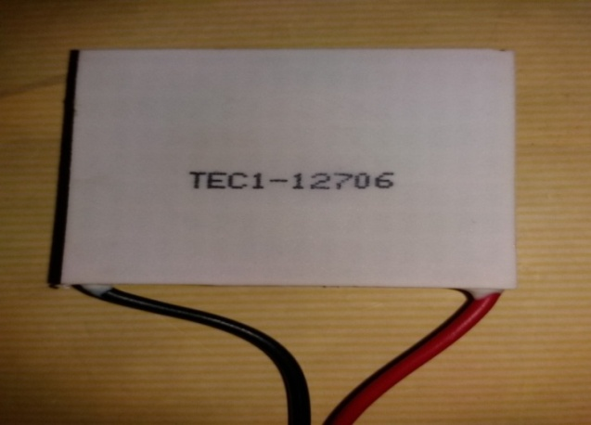

Fig 4: TEC Module

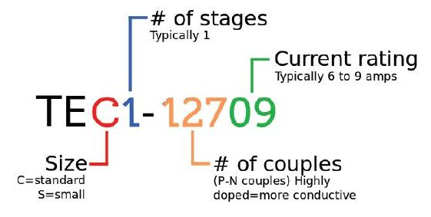

Fig 5: Explanation of number on tec

**Performance Curve**



Fig 6: Performance Curve



Fig 7: Dimension of tec

Where,

A = 40mm,

B = 40mm,

C = 3.9mm.

**Operating Tips**

* Max. Operating Temperature: 138oC
* Do not exceed Imax or Vmax when operating module.
* Please consult HB for moisture protection options (sealing).
* Life expectancy: 200,000 hours
* Failure rate based on long time testing: 0.2%.

**Battery**

The battery is an electrochemical converting chemical energy into electrical energy.

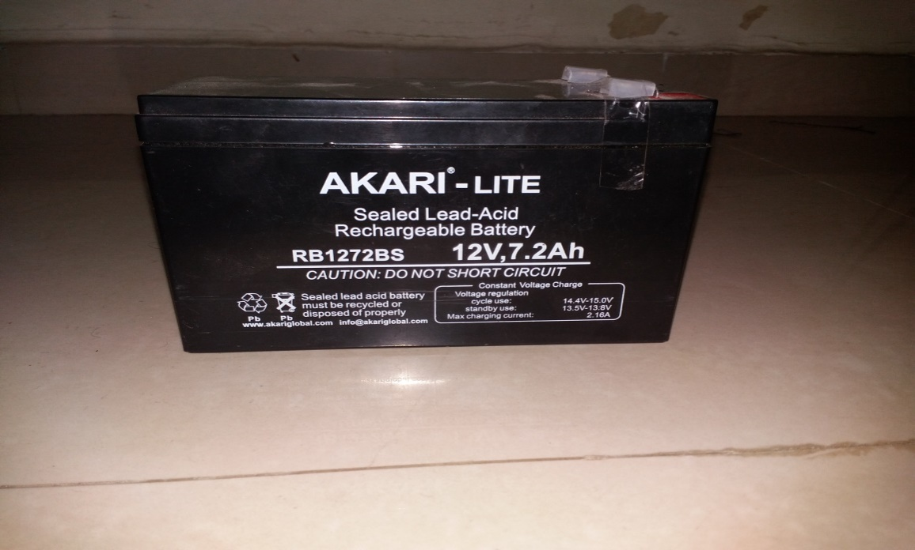

Fig 8: Battery

The main purpose of the battery is to provide a supply of current for operating the cranking motor and other electrical units.

Specification:

1. Voltage 12v

2. Current 7.2Ah

### **2.1.2. Solar cell**

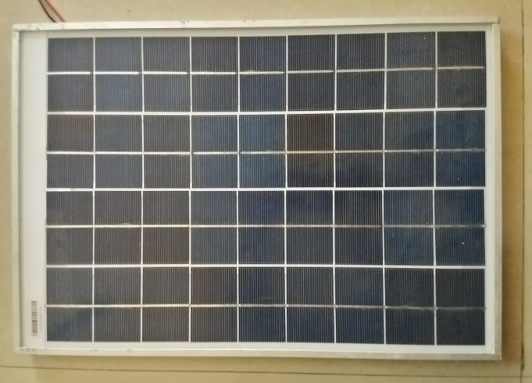

Fig 9: Solar Panel

The direct conversion of solar energy is carried out into electrical energy by conversion of light or other electromagnetic radiation into electricity.

1. The dimensions of the panel are-

* Length – 48.5 cm,
* Width – 35 cm.

2. Number of sub-cells used is 72

3. Dimension of the sub-cells is,

* Length – 4.8 cm
* Width – 4 cm.

4. Maximum power is 20 W

5. Voltage is 17 V

6. Current is 1.16 A

Solar cells collect light from the sun and turn it into electricity. They do this in the following way.

* Energy from the sun falls on a thin slice of a silicon-based material
* This causes the silicon material to have more energy, the electrons in the material move around faster
* Moving electrons create electricity
* The heat energy makes the electric current flow from the silicon material
* The greater the intensity of the sunlight the greater the amount of electricity produced
* The output from a solar cell is at its greatest when the light hits the cell at right angles.
* The amount of electrical power generated is affected by the temperature around the solar cell

**Solar Cell Operation**

Solar cells convert light energy into electrical energy either indirectly by first converting it into heat, or through a direct process known as the photovoltaic effect. The most common types of solar cells are based on the photovoltaic effect, which occurs when light falling on a two-layer semiconductor material produces a potential difference, or voltage, between the two layers. The voltage produced in the cell is capable of driving a current through an external electrical circuit that can be utilized to power electrical devices. This tutorial explores the basic concepts behind solar cell operation.

The tutorial initializes at an arbitrarily set "medium" photon intensity level, with photons randomly impacting the surface of the solar cell to generate free electrons. The released electrons complete a simple circuit containing two light bulbs that become illuminated when current flows through. In order to increase or decrease the photon flux, use the Photon Intensity slider to adjust the number of photons incident on the surface.

Today, the most common photovoltaic cells employ several layers of doped silicon, the same semiconductor material used to make computer chips. Their function depends upon the movement of charge-carrying entities between successive silicon layers. In pure silicon, when sufficient energy is added (for example, by heating), some electrons in the silicon atoms can break free from their bonds in the crystal, leaving behind a hole in an atom's electronic structure. These freed electrons move about randomly through the solid material searching for another hole with which to combine and release their excess energy. Functioning as free carriers, the electrons are capable of producing an electrical current, although in pure silicon there are so few of them that current levels would be insignificant. However, silicon can be modified by adding specific impurities that will either increase the number of free electrons (n-silicon), or the number of holes (missing electrons; also referred to as p-silicon). Because both holes and electrons are mobile within the fixed silicon crystalline lattice, they can combine to neutralize each other under the influence of an electrical potential. Silicon that has been doped in this manner has sufficient photosensitivity to be useful in photovoltaic applications.

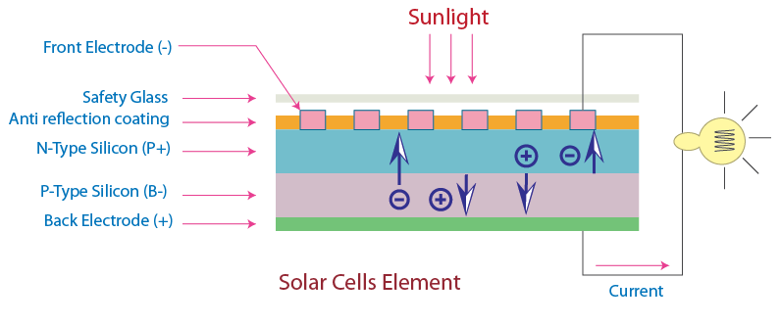

Fig 10: Working of solar

In a typical photovoltaic cell, two layers of doped silicon semiconductor are tightly bonded together (illustrated in Figure). One layer is modified to have excess free electrons (termed an n-layer), while the other layer is treated to have an excess of electron holes or vacancies (a p-layer). When the two dissimilar semiconductor layers are joined at a common boundary, the free electrons in the n-layer cross into the p-layer in an attempt to fill the electron holes. The combining of electrons and holes at the p-n junction creates a barrier that makes it increasingly difficult for additional electrons to cross. As the electrical imbalance reaches an equilibrium condition, a fixed electric field results across the boundary separating the two sides.

When light of an appropriate wavelength (and energy) strikes the layered cell and is absorbed, electrons are freed to travel randomly. Electrons close to the boundary (the p-n junction) can be swept across the junction by the fixed field. Because the electrons can easily cross the boundary, but cannot return in the other direction (against the field gradient), a charge imbalance results between the two semiconductor regions. Electrons being swept into the n-layer by the localized effects of the fixed field have a natural tendency to leave the layer in order to correct the charge imbalance. Towards this end, the electrons will follow another path if one is available. By providing an external circuit by which the electrons can return to the other layer, a current flow is produced that will continue as long as light strikes the solar cell. In the construction of a photovoltaic cell, metal contact layers are applied to the outer faces of the two semiconductor layers, and provide a path to the external circuit that connects the two layers. The final result is production of electrical power derived directly from the energy of light.

The voltage produced by solar cells varies with the wavelength of incident light, but typical cells are designed to use the broad spectrum of daylight provided by the sun. The amount of energy produced by the cell is wavelength-dependent with longer wavelengths generating less electricity than shorter wavelengths. Because commonly available cells produce only about as much voltage as a flashlight battery, hundreds or even thousands must be coupled together in order to produce enough electricity for demanding applications. A number of solar-powered automobiles have been built and successfully operated at highway speeds through the use of a large number of solar cells. In 1981, an aircraft known as the *Solar* Challenger, which was covered with 16,000 solar cells producing over 3,000 watts of power, was flown across the English Channel powered solely by sunlight. Feats such as these inspire interest in expanding the uses of solar power. However, the use of solar cells is still in its infancy, and these energy sources are still largely restricted to powering low demand devices.

Current photovoltaic cells employing the latest advances in doped silicon semiconductors convert a average of 18 percent (reaching a maximum of about 25 percent) of the incident light energy into electricity, compared to about 6 percent for cells produced in the 1950s. In addition to improvements in efficiency, new methods are also being devised to produce cells that are less expensive than those made from single crystal silicon. Such improvements include silicon films that are grown on much less expensive polycrystalline silicon wafers. Amorphous silicon has also been tried with some success, as has the evaporation of thin silicon films onto glass substrates. Materials other than silicon, such as gallium arsenide, cadmium telluride, and copper indium dieseline, are being investigated for their potential benefits in solar cell applications. Recently, titanium dioxide thin films have been developed for potential photovoltaic cell construction. These transparent films are particularly interesting because they can also serve double duty as windows.

Converting Photons to Electrons, the solar cells that you see on calculators and satellites are photovoltaic cells or modules (modules are simply a group of cells electrically connected and packaged in one frame). Photovoltaic, as the word implies (photo = light, voltaic = electricity), convert sunlight directly into electricity. Once used almost exclusively in space, photovoltaic are used more and more in less exotic ways. They could even power your house. How do these devices work?

Photovoltaic (PV) cells are made of special materials called semiconductors such as silicon, which is currently the most commonly used. Basically, when light strikes the cell, a certain portion of it is absorbed within the semiconductor material. This means that the energy of the absorbed light is transferred to the semiconductor. The energy knocks electrons loose, allowing them to flow freely. PV cells also all have one or more electric fields that act to force electrons freed by light absorption to flow in a certain direction. This flow of electrons is a current, and by placing metal contacts on the top and bottom of the PV cell, we can draw that current off to use externally. For example, the current can power a calculator. This current, together with the cell's voltage (which is a result of its built-in electric field or fields), defines the power (or wattage) that the solar cell can produce.

That's the basic process, but there's much more to it. Let's take a deeper look into one example of a PV cell: the single crystal silicon cell.

# **3. DESIGN AND METHODOLOGY**

## **3.1. CAD Model**

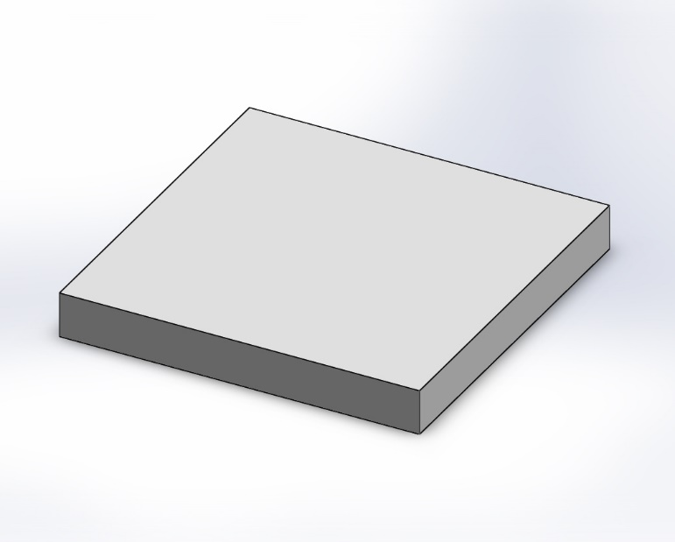

Fig 11: Peltier Module

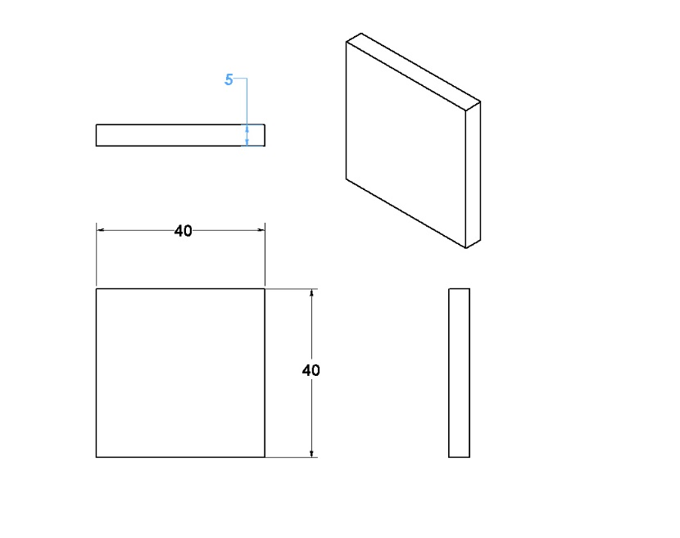

Fig 12: Drafting of Peltier module

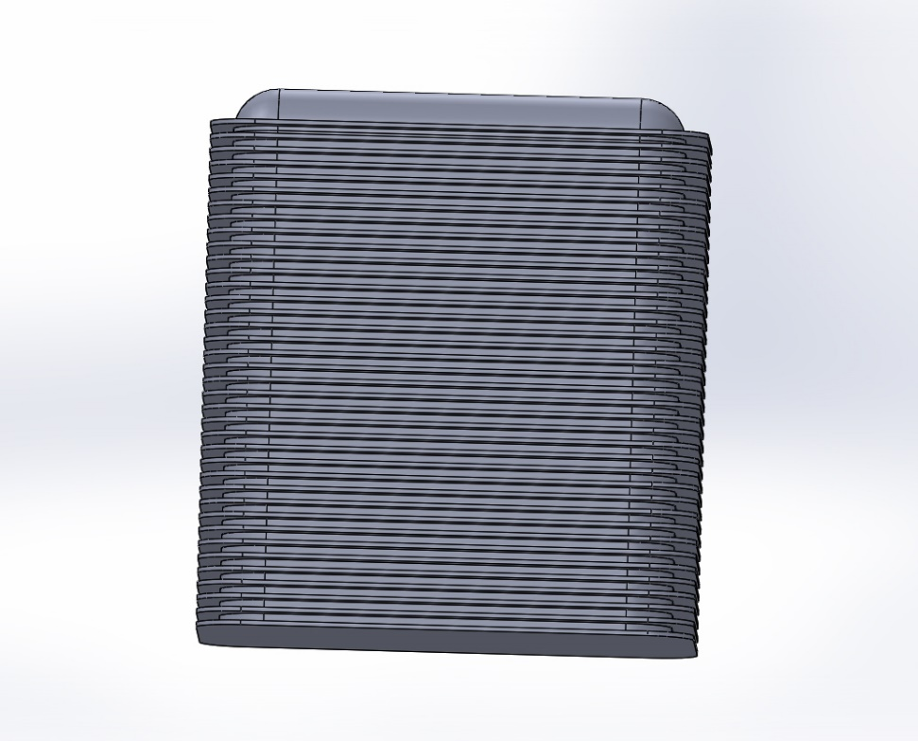

Fig 13: Heat Sink

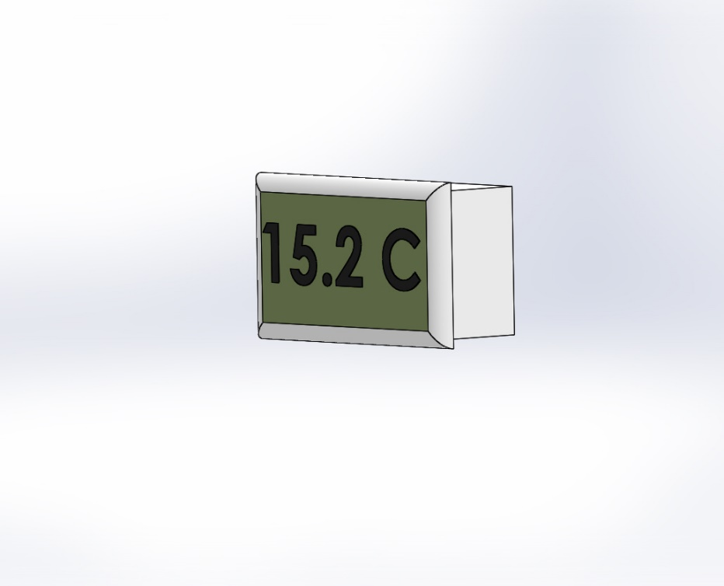

Fig 14: Temperature Sensor

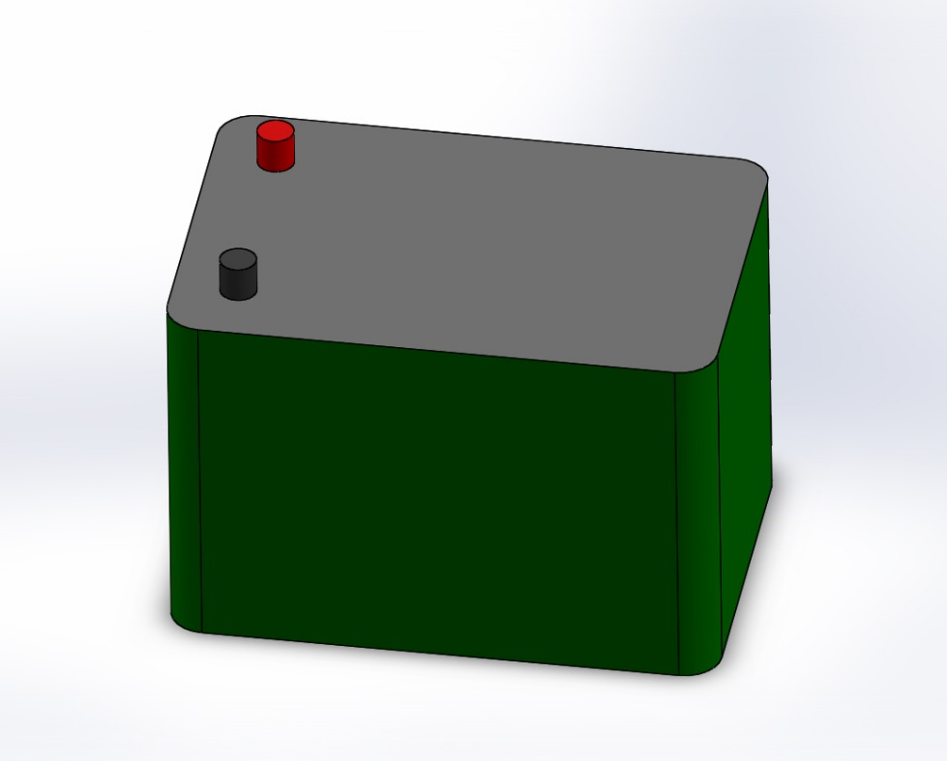

Fig 15: Battery

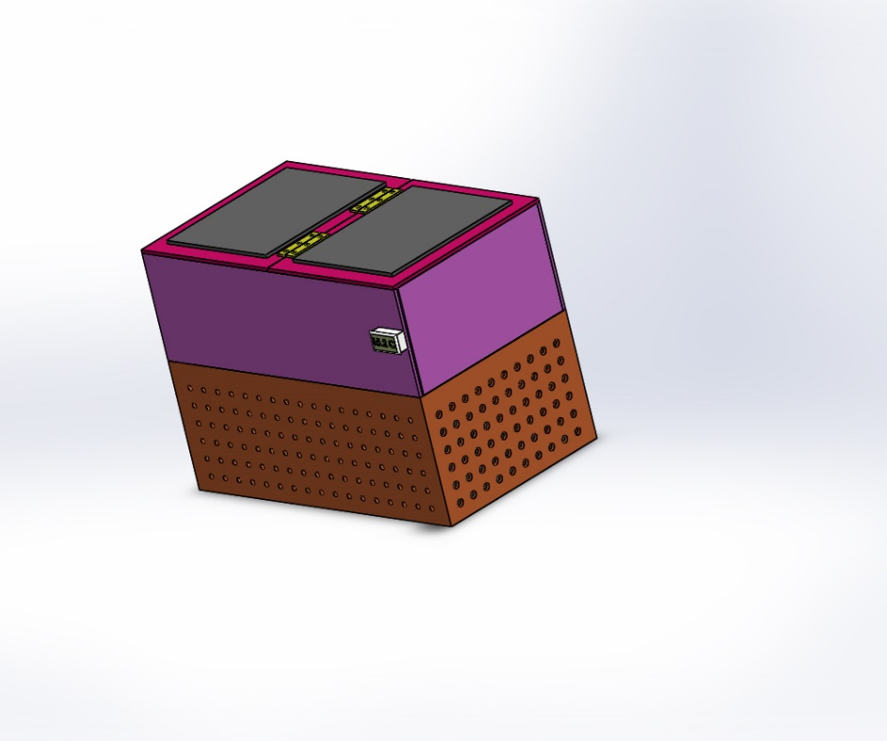

Fig 16: Isometric view

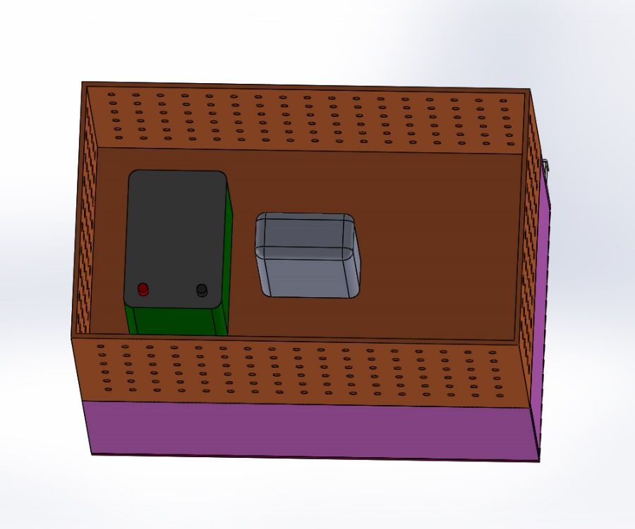

Fig 17: Assembly

## **3.2. Calculation**

In this we calculate two types of load Heat absorbing load in the cabin and Heat rejection load through the outside Heat sink fan.

First, we have to calculate how much amount of power is required to absorb the heat of a 14 cubic meter size of volume box at 35°coutside Temperature. So, there is a heat-absorbing load formula Q = m*Cp*(Th- Tc). so we have to calculate Mass.

Mass = Density * volume = 1000*0.014 = 14 kg

Q = m*Cp*(Tamb -Tc) = 14*4.187*(35 -15) = 1172.36 KJ = 326 watt-h or 163 watt in 2 hr

So, we required a total 163-watt heat-absorbing load in a 14 cubic meter volume box to reach 15°c in 163 watts we select 6 Peltier each Peltier would take 28 watts of load to cool up to 15°c

## **3.3. Selection of Material**

A. Peltier

Above calculation of cabin load for per Peltier, we required 28 watts and 12v dc supply 2.3 amperes current for this amount of power we select TEC1-12706 Module Peltier that characteristic is

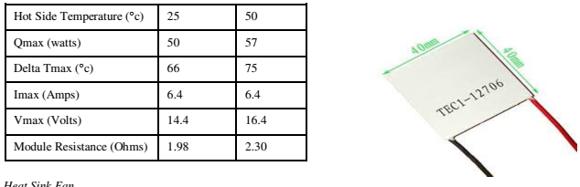

Table 1: Peltier Characteristics

B. Heat Sink Fan

Heat rejection Load = Q = h*A (Th-Tc)

= 15 * 5.1*(50-35) = 0.31 = 0.31 watt-h per Heat sink Fan

Total we require watt-h for Heat rejection Load

We select 0.6 ampere 12v heat sink fan

The total Max power taken to reject heat is 7.2 watts per Peltier Total of 6 Peltier max power to reject heat is 43.2 = 44watt

Total watt required = heat absorb load + heat reject load = 163+44 = 207 watt-h

207-watt Total power required to remove the heat in 14 cubic meter volume box heat till 15°c

C. Selection of Battery

For 207 watt amount of load we required a battery to run this load hence we calculate capacity of battery.

Power calculation = Voltage Load * Current Load = 12*3 (∴ 3 = 2.33+0.6) = 36 watt

Battery capacity = total load / battery voltage = 207/12 = 17.25 Ah

We select 20 Ah battery to run this refrigerator to charge the battery we select Flate Plate solar panel We need a Charge the battery in 4hr

20Ah/4H = 5A

5A*12V = 60watt

100-watt Solar Panel Require Charge Battery in require time

The output power of solar panel = 60W

Total power generated by solar panel = 100W

Total time required to charge the battery = Watt-hour of Battery / output power of solar panel= 240/60 = 4hr

Hot Side Temperature (°c) 25 50

Qmax (watts) 50 57

Delta Tmax (°c) 66 75

Imax (Amps) 6.4 6.4

Vmax (Volts) 14.4 16.4

Module Resistance (Ohms) 1.98 2.30

## **3.4. Activity Chart**

|  |  |  |  |  |  |  |  |  |  |  |  |  |
| --- | --- | --- | --- | --- | --- | --- | --- | --- | --- | --- | --- | --- |
| Months/  Activity | **Jun** | **Jul** | **Aug** | **Sep** | **Oct** | **Nov** | **Dec** | **Jan** | **Feb** | **Mar** | **Apr** | **May** |
| A |  |  |  |  |  |  |  |  |  |  |  |  |
| B |  |  |  |  |  |  |  |  |  |  |  |  |
| C |  |  |  |  |  |  |  |  |  |  |  |  |
| D |  |  |  |  |  |  |  |  |  |  |  |  |
| E |  |  |  |  |  |  |  |  |  |  |  |  |
| F |  |  |  |  |  |  |  |  |  |  |  |  |
| G |  |  |  |  |  |  |  |  |  |  |  |  |
| H |  |  |  |  |  |  |  |  |  |  |  |  |
| I |  |  |  |  |  |  |  |  |  |  |  |  |
| J |  |  |  |  |  |  |  |  |  |  |  |  |

**ACTIVITIES**

* A= Topic finalization
* B= Literature Review
* C= Formulation of Problem
* D= Parametric analysis
* E=Development of CAD models of system
* F= Purchasing of components
* G= Manufacturing
* H= Assembly and Testing
* I= Results and Conclusion
* J= Report Writing

## **3.5. Methodology**

* + - Since design of system is an important aspect in automotive industries. So, in the similar kind of way, proper material selection and selection of manufacturing process is also an important aspect.
    - For project we have selected material and manufacturing processes as per the budget permitted us.

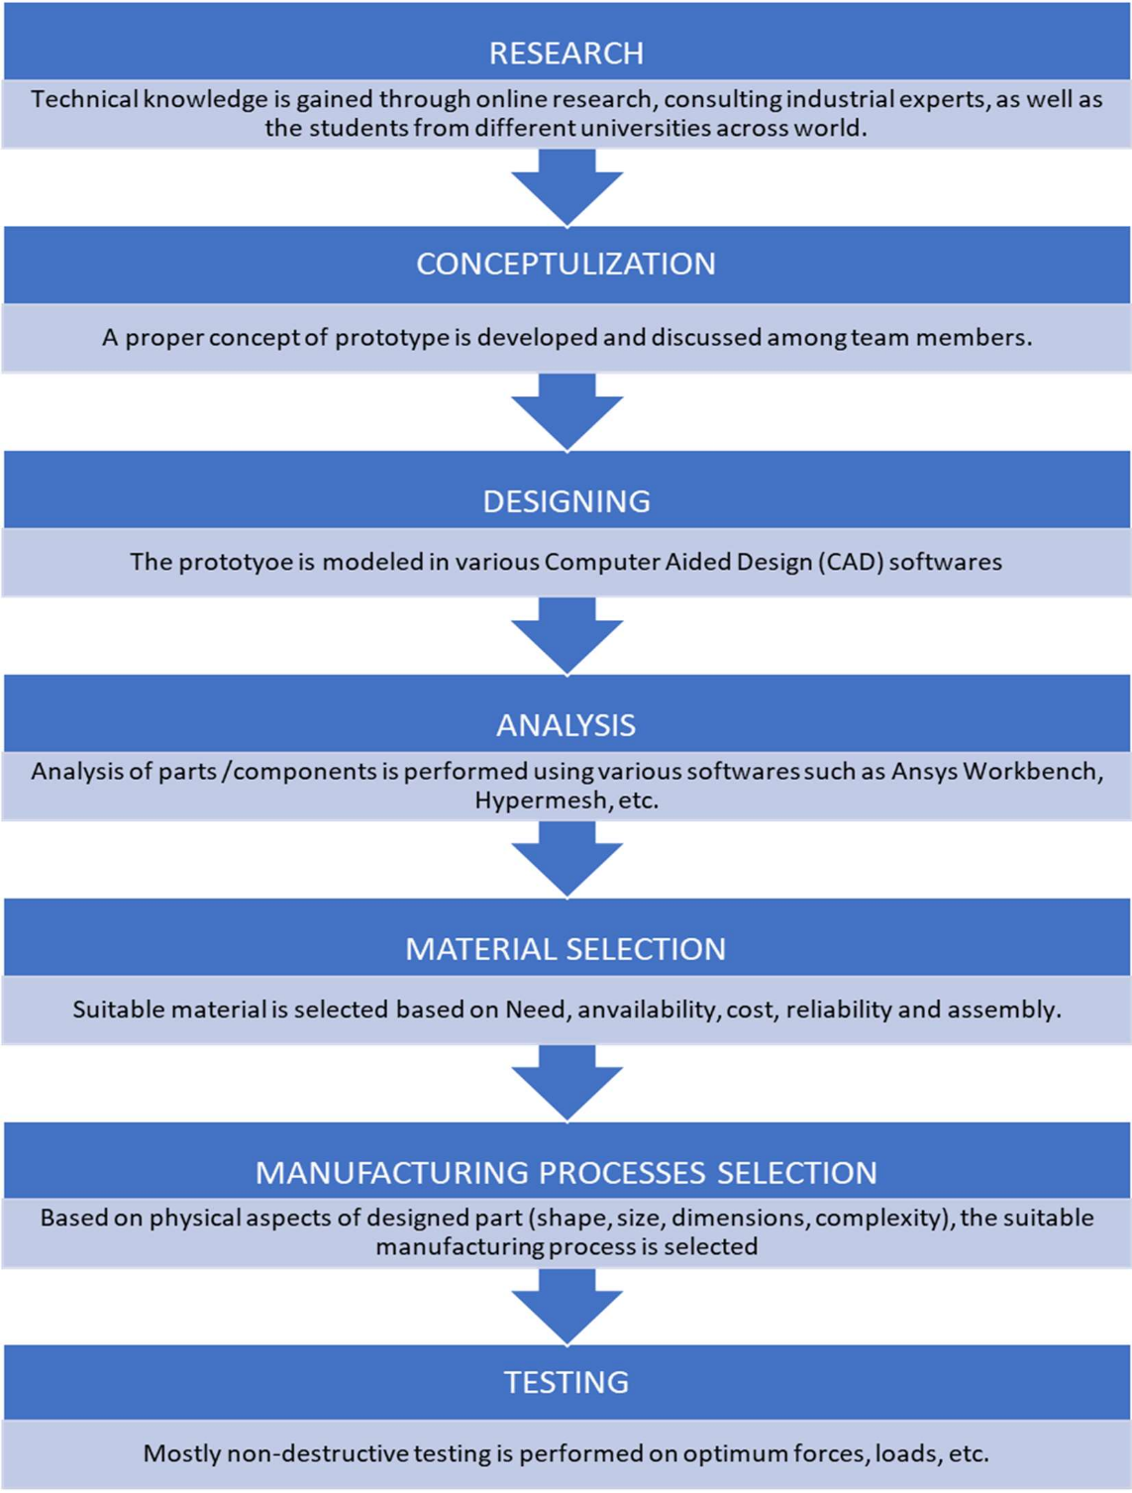

## **3.6. Advantages**

1. Light weight and compact for very small heat loads.
2. No CFC gases or refrigerant are used for cooling.
3. No moving parts, eliminating vibration, noise, and problems of wear.
4. Reversing the direction of current transforms the cooling unit into a heater.
5. Operates in any orientation.
6. Not affected by gravity or vibration.
7. Very low-cost device for cooling in small appliances.
8. Precision temperature control capability.
9. It can be used in drought affected areas.

10.Solar operation makes it more economical and environment friendly

## **3.7. Disadvantages**

1. Limited to very small refrigeration loads due to size compaction.
2. Not suitable for higher refrigeration use due to poor efficiency.
3. Thermo-electric modules become very heavy and bulky as the refrigeration capacity increases.
4. The technology is normally used only to cool small surfaces (for example a processor in a computer) since there have been complications when making the system bigger.

## **3.8. Applications**

1. Electronics — miniature cooling units for incoming stages of highly sensitive receivers and amplifiers; coolers for high power generators, laser emitters and systems, CCD cameras, parametric amplifiers, vacuum and solid-state photo detectors and CPU coolers.
2. Medicine — mobile cooling containers for storage and transportation of tissue, blood, liquids, etc, ophthalmological devices for crystal lens transplantation, micro pincers, cooling blankets and sheets, dermatology treatment devices.
3. Anaesthesiology equipment, cosmetic and pharmaceutical items, scalp coolers to minimise hair loss during chemotherapy.
4. Scientific and Laboratory Equipment — cooling chambers, freezers, cooling incubators, temperature stabilized chambers, cold laboratory plates and tables, thermo-calibrators stage coolers, thermostats, coolers and temperature stabilisers for multipurpose sensors.
5. Consumer Goods — portable picnic boxes, drinking water and beverage coolers, cooling boxes and cabinets for stores and cafes, massage equipment.
6. Climate Devices — multipurpose thermoelectric conditioners, airflow cooling fans, room air conditioner-humidifiers for electronics racks, cabinets, libraries (including video libraries), temperature stabilisers for aquariums and terrariums.

7.Automotive — seat cooling and heating for climatic seats, driver in-cab face and drink cooling for buses, tractors, mechanical diggers, trucks; coolers for motorcycle helmets.

# **4. CONCLUSION**

## **4.1. Conclusion**

The Peltier Refrigerator is made of 4 collapsible metal walls. It breaks down flat for storage and then pops up with an extendable handle for schlepping along on road trips, tailgates, and rustic(ish) tent getaways, or just setting up by the pool for easy refreshment access during the summer. Its top solar panels absorb sunlight all day long, using some of this energy to run the fridge during daytime hours, and the rest to charge the ion battery that keeps the fridge outputting cold air all night long. The battery can also be charged using a standard outlet or car cigarette lighter and serves to power 2 built-in USB ports for device charging.

With small and large sizes available, the Peltier Refrigerator proposes to replace heavy, sometimes sloshy coolers and ice chests. Its programmable temperature settings range from -8 degrees F to 75 degrees F, and a Fast Freeze function is able to rapidly drop the cooler's temperature to its -8 low. Small Anywhere Fridges weigh 20 pounds and have a 30-quart storage capacity. Large versions weigh 40 pounds and can store 80 quarts of food and drinks. Small dimensions: 12" long x 9" tall x 18" deep. Large dimensions: 25" long x 10" tall x 19" deep.

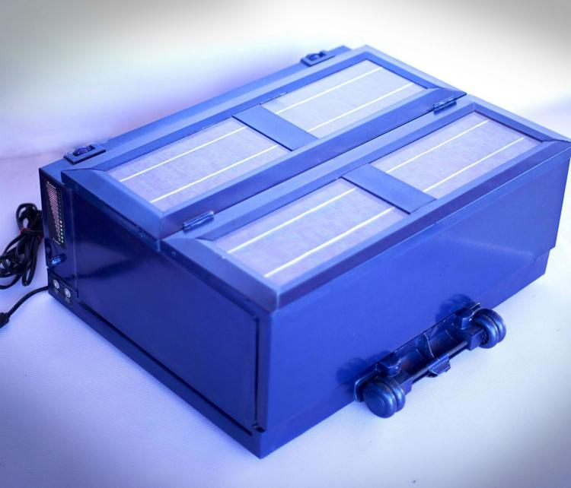

## **4.2. Advantages of Having a Portable Mini Fridge**

It doesn’t matter if you need to have some extra space to store food items in your house or if you simply want to ensure that your drinks are always cold wherever you are, then a portable mini fridge is the best option you have to enjoy a nice cool drink and also to transport perishable items wherever you go. You will have the chance to take it with you whenever you want to go on an outdoor excursion with your friends and family or even take it with you to your office with your lunch.

Apart from the most obvious uses for the portable mini fridge, when you get this kind of fridge you will get many other benefits too. Since there is a wide variety of portable mini fridges on offer on the market, you won’t get any difficulties to find one that suits your needs. Let’s have a look at some of the benefits you will get when you buy a mini fridge.

More storage space: the most important benefit a portable mini fridge will give you when you get it is that you will be able to have some more storage space for keeping pieces of meat, drinks and any other food you need to chill. If you have problems with the size of your freezer, you can simply use the portable mini fridge to get that extra storage space you need. Apart from keeping food items cool, the mini fridge is useful to defrost things as well.

No problem when transporting products: as you might probably expect, the most evident benefit of using a portable mini fridge is the ability you will have to take drinks and food items that need a low temperature wherever you go. As it’s not difficult to get a portable mini fridge, you will feel better when you get everything you need at the market and taking your stuff to your house. If you have a mini fridge, you will be able to have a better summer, especially if you like sunbathing and traveling long distances either on holiday or to work.

1. Portable Mini Fridge
2. Portable

Due to its much more compact size, a mini refrigerator can be transported with no hassle. Carrying it is truly hassle-free so taking it to trips is among the list of several positive aspects of having a mini fridge. Lots of people would like to travel during their recreational activities and a mini fridge is a good approach to carry treats on the journey. No matter what the location, a mini fridge can be easily set up conveniently. Mobility is the top benefit of the mini fridge. Convenience in any kind of device is a benefit that nearly all people are searching for and a mini refrigerator provides this value added characteristic to these individuals with an advantage.

### **4.2.1. Positioning**

Presence of mini refrigerators seem to be found in family homes, patios, dorms, recreational vehicles and even in office buildings. It may be set according to your preferences wherever you might be likely to situate the mini refrigerator. Everyone is remarkably pleased with the number of benefits which is available from a mini refrigerator. Dormitory rooms are a trendy location for keeping mini fridges. It takes up a smaller amount area and keeps all your food items fresh. Goods like alcohol, snack food items as well as various meats slices can be stored in a mini refrigerator. It even performs soundlessly for this reason there is not any interference, in any respect, to the students and that means no more disagreements about disturbance in the dorm. You can keep a mini fridge just about anywhere you desire making this the most amazing product to acquire.

### **4.2.2. Reliable With Energy**

Recharging the batteries of a mini fridge requires a very minuscule period of time which makes it feasible to be taken on travels. It is the most economical product that anyone could invest in with its capability to save energy and as a result reduce the consumption of electrical power. Using these compact fridges for lengthy durations is made effortless because their batteries persist hours on end.

### **4.2.3. Fits Just About Anywhere**

It’s actually probably the most lightweight refrigeration models and can be positioned in even the most confined areas. Another good thing about mini fridges is that they are available in variations and models so you’re able to invest in as outlined by your specifications.

### **4.2.4. Ease and Comfort**

TE technology has found application in wide variety of areas since the last 40 years. The TE devices can act as coolers, heat pumps, power generators, or thermal energy sensors and are used in almost all the fields such as military, aerospace, instrument, biology, medicine, industrial or commercial products.

The major challenge faced in TE cooling is lower COP especially in large capacity systems. However, as the energy costs are elevating and environmental regulations regarding the manufacture and release of CFCs have become more firm with time, the scope of TE effect has revived, especially in the developing countries or the third world where the energy is not surplus. TE chilling of milk can be done at the farm level to inhibit any enzymatic or microbial change in quality of the milk. The TEC can reduce the temperature of the milk to 40°C to attain stability in terms of bacterial count. Research in `the field of thermoelectricity and experimentation with different materials is required to improve the COP of the TE cooler. Advancements have taken place and various prototypes in different fields utilizing thermoelectricity have been made besides other conventional refrigeration applications. In the coming years thermoelectricity has a lot of potential to create energy saving and effective solutions for the industry and commercially as well.

## **4.3. FUTURE SCOPE**

**There are some points that could be researched in future:**

* Using two TECs in different configurations.
* Developing a power sharing PV regulator.

### **4.3.1. Using Two TECS Totalling the Designed Qc**

Smaller TECs could be connected in parallel with a combined Qc value equal to the design Qc value. The whole idea being that a two-step cooler box could be developed that can operate at half power or at full power, depending on one or both TECs being powered. This would simplify the design of a power sharing regulator since the power to the cooler box does not need to be regulated in conditions where it is required to operate at half of the maximum input power.

### **4.3.2. Developing a Suitable Power Sharing Regulator**

A power sharing regulator should be developed for the cooler box. This regulator should be able to regulate the amount of power received from the PV panel and distribute it to battery and the cooler box in such a manner that the system works at peak efficiency. This means the battery being fully charged, the excess power would be channelled to the cooler box. At night, the regulator should provide the cooler box with just enough current to maintain the inside temperature until the next day.

Further research should be done on the different possibilities to see if a better COP could be achieved. This is important since the power from a PV panel is limited due to cost. A power sharing regulator should be developed, and the performance should be tested (depending on the TEC configuration that is used), and the whole system should be tested in real life conditions to see how effective it operates.

# **REFERENCES**

[1] Angamuthu. K, A. D. (2020). Design and Manufacturing of Thermoelectric Mini Portable Refrigerator using Autodesk Fusion 360 with Additive Manufacturing. IJRTE, 7.

[2] Awasti, M., & Mali, K. (2012). Design and Development of Thermoelectric Refrigerator. International Journal of Mechanical Engineering and Robotics Research(Volume No. 3), 11.

[3] Chetan Jangonda, K. P. (2016). Review of various Applications of Thermoelectric Module. IJIRSET, 8.

[4] D. SUMAN, P. H. (2020). DESIGN AND FABRICATION OF THERMOELECTRIC REFRIGERATOR USING PELTIER MODULE. JETIR, 7(3), 5.

[5] Elavarasan E, S. S. (2018). Design and Fabrication of Mini Refrigerator with Thermoelectric Cooling. IJERT, 4.

[6] Gagan Bansal, Y. j. (2021). Solar Based polio-drop box system with Peltier effect technology: A review. ELsevier, 6.

[7] Jatin Patel, M. P. (2016). Improvement in the COP of Thermoelectric Cooler. IJSTR, 4.

[8] José Armando Gastelo-Roque, A. M.-A. (2017). Design of a photovoltaic system using thermoelectric Peltier Cooling for Vaccine Refrigeration. IEEE, 4.

[9] Kshitij Rokde.Mitali Patle, T. k. (2017). Peltier Based Eco-Friendly Smart Refrigerator for Rural Areas. IJARCSSE, 4.

[10] Pawan Attavane, A. G. (2017). Solar Powered Portable Food warmer and cooler based on Peltier Effect. IEEE, 4.

[11] Rohit Sharma, V. K. (2009). Peltier Effect Based Solar Powered Air Conditioning System. IEEE, 5.

[12] Sabah A. Abdul-Wahab a, *. A. (2007). Design and experimental investigation of the portable solar thermoelectric refrigerator. ELSEVIER, 5.

[13] V.Rajangam, M. (2015). DESIGN AND CFD ANALYSIS OF THERMOELECTRIC COOLING SYSTEM. ICRAMET, 5.